XPath 1
Any non-empty string is true, including “false”!

XPath 2.0
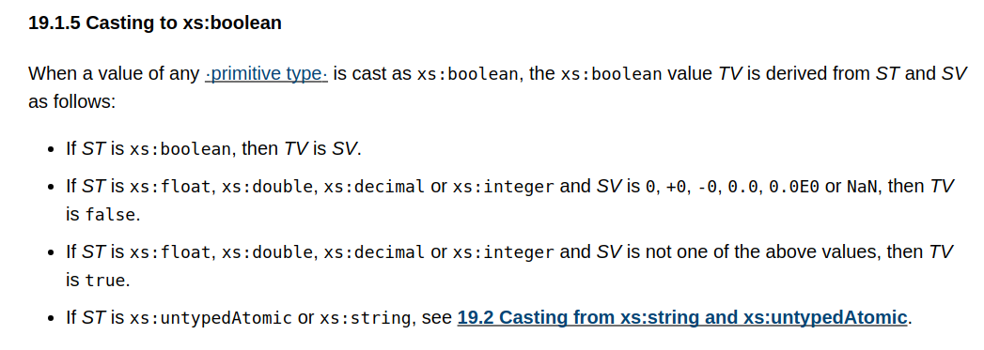

3.2.2 boolean
[Definition:] boolean has the ·value space· required to support the mathematical concept of binary-valued logic: {true, false}.

3.2.2.1 Lexical representation
An instance of a datatype that is defined as ·boolean· can have the following legal literals {true, false, 1, 0}.

Java
public static boolean parseBoolean(String s)
Parses the string argument as a boolean. The boolean returned represents the value true if the string argument is not null and is equal, ignoring case, to the string "true".
Example: Boolean.parseBoolean("True") returns true.
Example: Boolean.parseBoolean("yes") returns false.

